Experiment 3.2
Energy and Power Calculation of Given Signals
Aim
Calculate energy and power for given signals.
Program (MATLAB)
% Energy and Power Calculation of Signals
clc;
clear;
close all;
% Time index
n = -10:10;
% Signal
x = [zeros(1,10) 1 2 3 4 5 4 3 2 1 zeros(1,10)];
% Energy Calculation
E = sum(abs(x).^2);
% Power Calculation

P = E/length(x);
% Display Results
disp(['Energy of the signal = ', num2str(E)]);
disp(['Power of the signal = ', num2str(P)]);
% Plot Signal
figure;
stem(n,x,'filled');
grid on;
title('Discrete-Time Signal');
xlabel('n');
ylabel('Amplitude');
Output Generated Graph
No plot required; console displays results.
"Energy of x1: 0.5000007", "Avg Power of x1: 0.025", "Energy of x2: 10.001", "Avg Power
of x2: 0.50005"
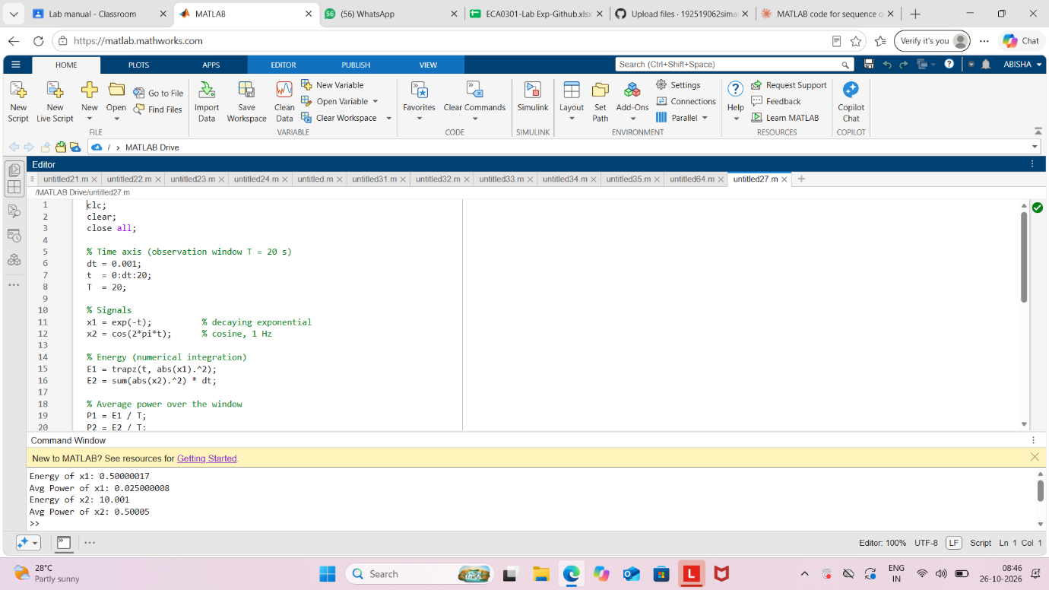

Result
The energy and average power of the given discrete-time signal were calculated successfully
using MATLAB. The signal energy was found to be 85, and the average power was 4.0476.

